|  |  |
| --- | --- |
| **TEAM ID** | PNT2022TMID38117 |
| **PROJECT TITLE** | Retail Store Stock Inventory Analytics |

PROJECT DEVELOPMENT PHASE DELIVERY OF SPRINT 4

REPORT CREATION

1. **SALES BY YEAR, MONTHLY REVENUE, REVENUE BY YEAR**

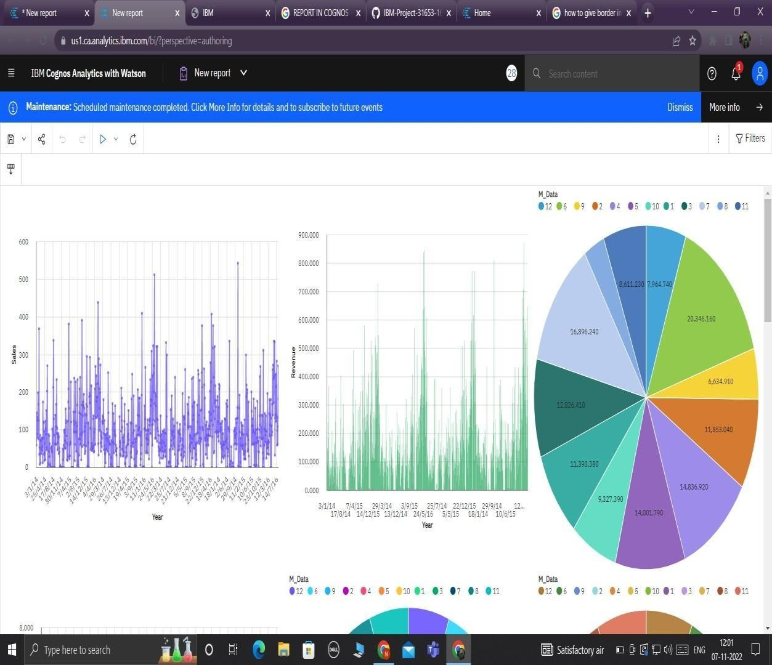

1. **MONTHLY SALES**

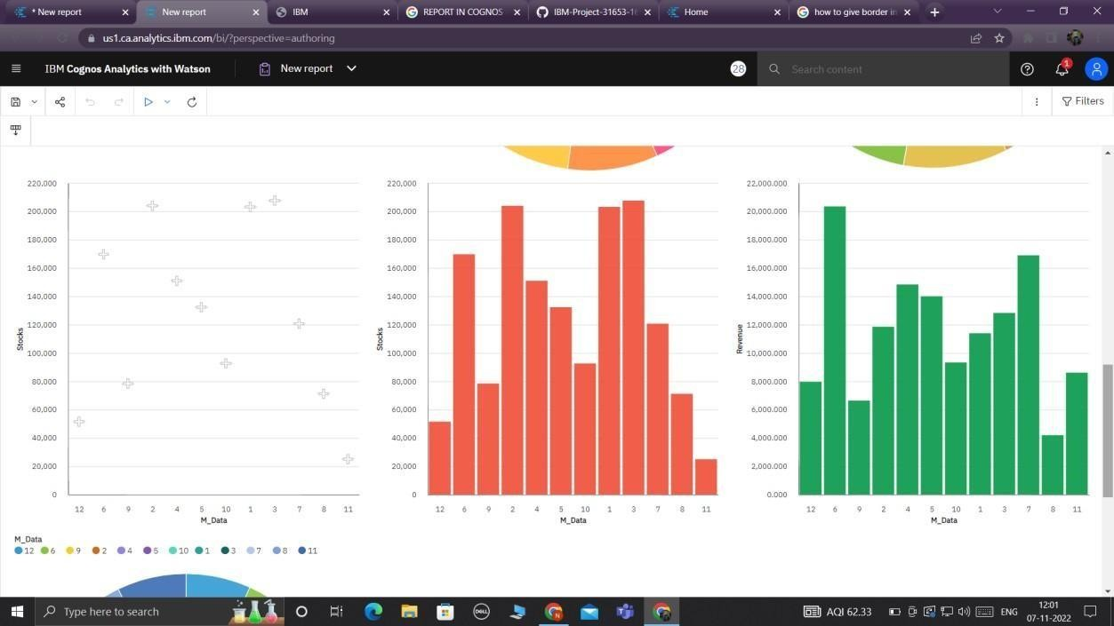

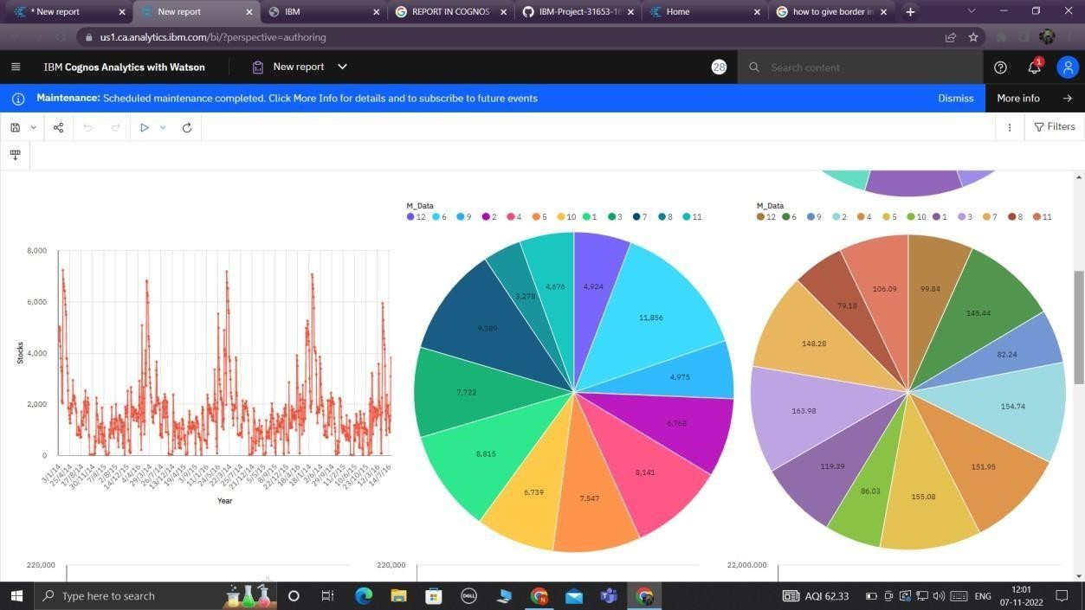

1. **MONTHLY STOCKS AND REVENUE**
2. MONTHLY PRICE

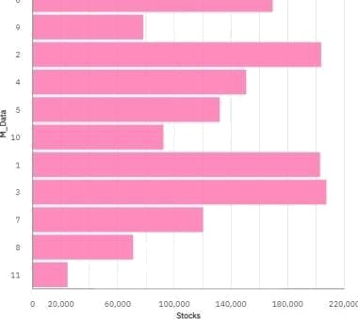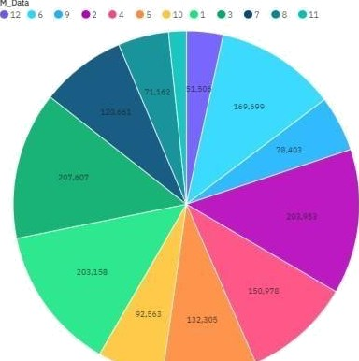

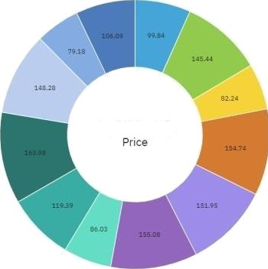

1,492.24





